**Pushing My file into Git hub by using command line**

**Step 1: Changed my directory to desktop**

**Step 2 : Linked my Repository to git Bash**

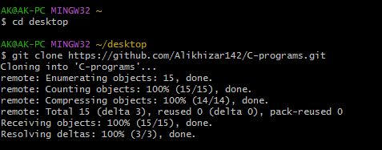

**Step 3: Changed by directory to my Repository (C-programs).**

**Step 4: Check status**

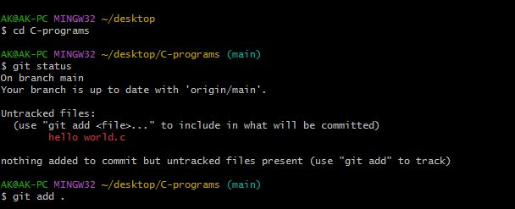**Step 5: Add my file to repository.**

**Step 6: Updated the status of my file.**

**Step 7: Pushed my file**

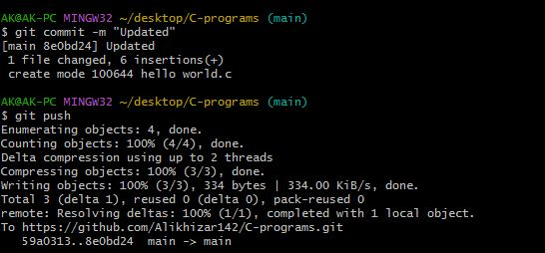

**Step 8: Edited my code on remote file.**

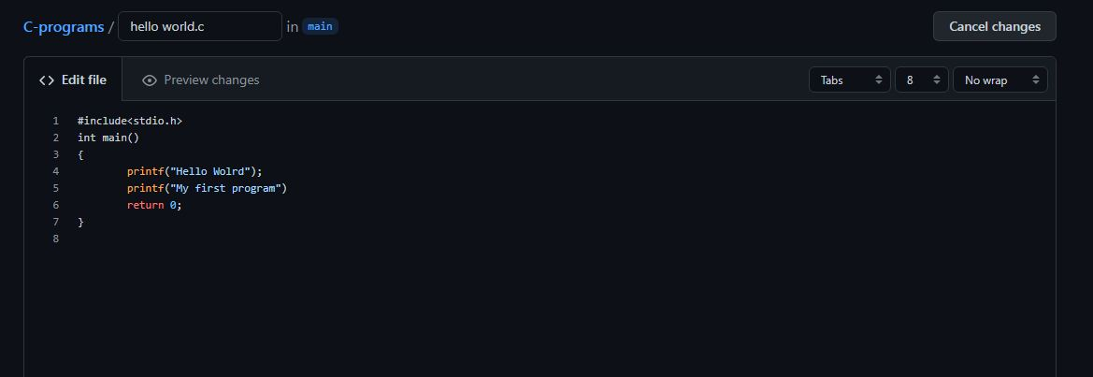

**You can check it on:** [**https://github.com/Alikhizar142/C-programs**](https://github.com/Alikhizar142/C-programs)

**Step 9: I pulled my remote file to local file .**

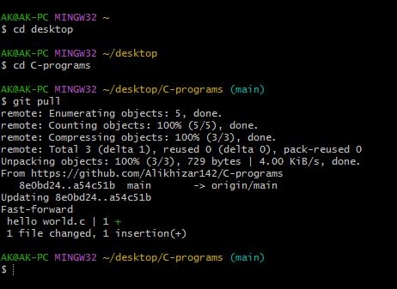

**AS you can see the change I made in my remote file are pulled into local file .**

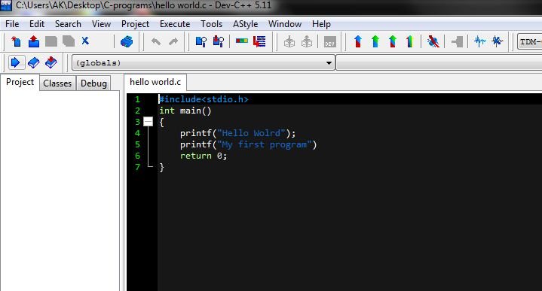

**Step 10: I made changes to my local read me file.**

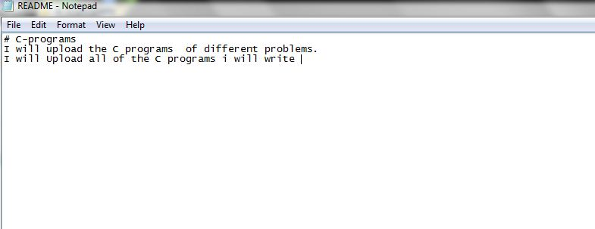

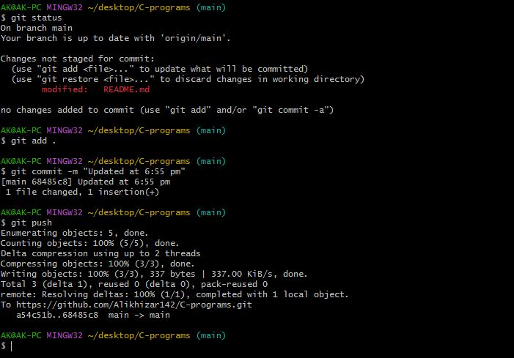**Step 11 : I pushed the changes I made to my read me file.**

You can check it at: <https://github.com/Alikhizar142/C-programs>